Assignm1

Ftp

Telnet

Finger

Mini Project:

Choose an application; group of 3; create directory structure and execute file management commands; form a hierarchy; execute filters; user management ; awk and perl;

**$nl :** The nl command reads the File parameter (standard input by default), numbers the lines in the input, and writes the numbered lines to standard output. In the output, the nl command numbers the lines on the left according to the flags you specify on the command line.

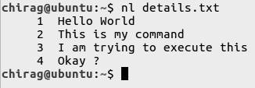

**$cut :** The cut command in UNIX is a command line utility for cutting sections from each line of files and writing the result to standard output. It can be used to cut parts of a line by byte position, character and delimiter. It can also be used to cut data from file formats like CSV.

1. **$cut -b : $cut -b** is used to cut specific number of bytes from a file and then display it.

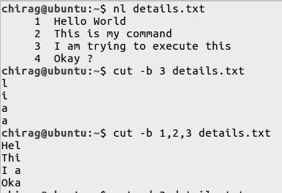

1. **$cut -d :** Instead of selecting x number of characters, if you like to extract a whole field, you can combine option -f and -d. The option -f specifies which field you want to extract, and the option -d specifies what is the field delimiter that is used in the input file.

